**Design Thinking Project Workbook**

**Don't find customers for your product but find products for your customers**

**1. Team**

**Team Name: Weather Forecasting**

**Team Members:**

1. Chandrahas, Creating The Code Of Project, 2320030041
2. Chaitanya, interaction with clients, 2320030396
3. Yashwanth, research of project in social platforms, 2320030388

**2. Problem/Opportunity Domain**

**Domain of Interest: Weather Forecasting Using AI**

**Description of the Domain:**

**weather forecasting is crucial for various industries, including agriculture, aviation, disaster management, and daily life. Traditional forecasting methods rely on numerical models, which often lack real-time adaptability. AI-based weather prediction systems use machine learning and deep learning techniques to analyze vast datasets from satellites, radars, and IoT sensors, offering more accurate and localized forecasts.**

**Why did you choose this domain?:**

1. **Personal interest in AI applications for real-world challenges.**
2. **Significant market potential in industries reliant on weather predictions.**

**3. Problem/Opportunity Statement**

**Problem Statement:**

**Current weather forecasting systems often fail to provide hyper-local, real-time predictions with high accuracy, leading to inefficiencies and economic losses.**

**Problem Description:**

**Weather forecasting relies on outdated numerical models, which struggle with real-time data integration and localized predictions. This results in less accurate forecasts, affecting industries and daily activities.**

**Context (When does the problem occur):**

1. **Before and during extreme weather events .**
2. **For industries needing precise forecasts.**

**Alternatives (What does the customer do to fix the problem):**

1. **Use traditional weather apps.**
2. **Rely on TV or radio forecasts.**

**Customers (Who has the problem most often):**

**Farmers, pilots, logistics companies, emergency responders, urban planners, and general consumers**

**Emotional Impact (How does the customer feel):**

1. **Anxious about potential financial and safety risks.**
2. **Uncertain when making weather-dependent decisions.**

**Quantifiable Impact (What is the measurable impact):**

* **Economic losses due to inaccurate forecasts**
* **Increased risk to human life in natural disasters.**

**Alternative Shortcomings (What are the disadvantages of the alternatives):**

1. **Traditional models have slow processing times and lower accuracy.**
2. **IoT-based solutions require extensive infrastructure investments.**

**Any Video or Images to showcase the problem:**

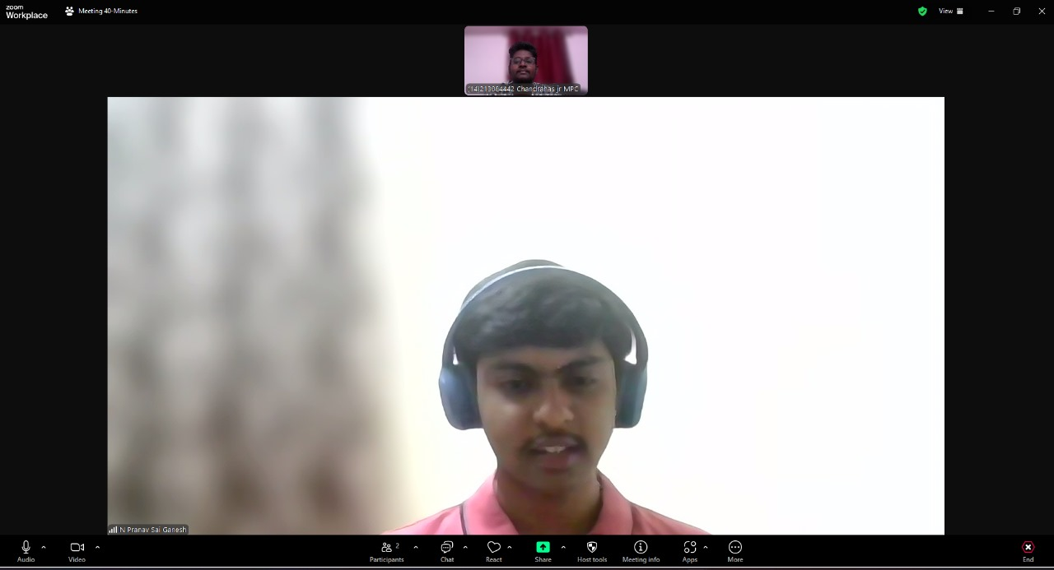

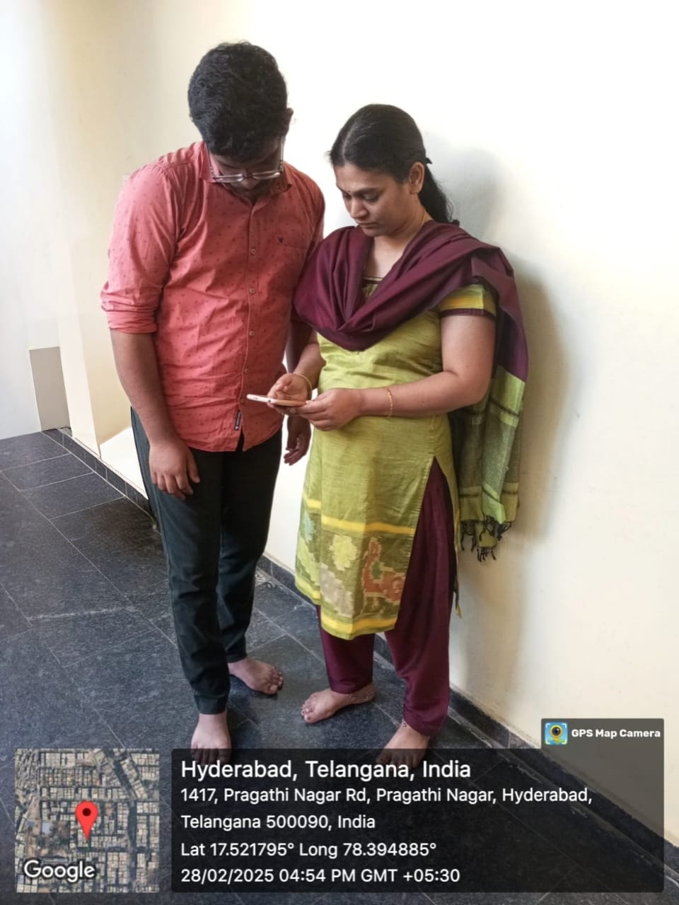

**3. Addressing SDGs**

**Relevant Sustainable Development Goals (SDGs):**

**SDG 13: Climate Action**

**SDG 9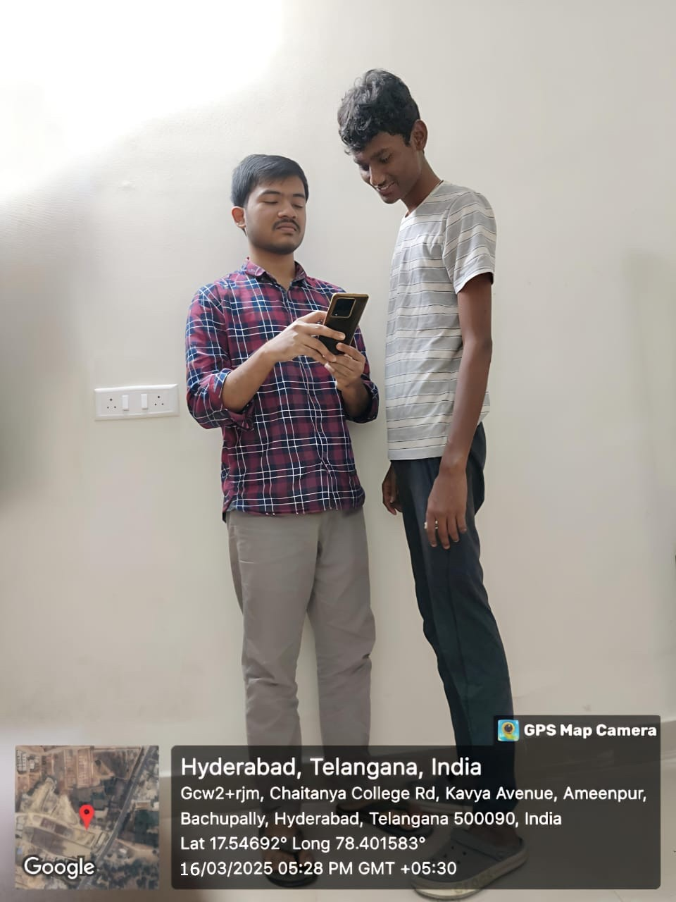: Industry, Innovation, and Infrastructure**

**How does your problem/opportunity address these SDGs?:**

**Improved forecasting can mitigate climate-related disasters.**

**AI-driven solutions enhance technological innovation in meteorology.**

**4. Stakeholders**

Answer these below questions to understand the stakeholder related to your project

1. **Who are the key stakeholders involved in or affected by this project?**

Meteorological agencies, AI researchers and data scientists, Government and disaster management authorities, Agriculture and logistics industries, General public

1. **What roles do the stakeholders play in the success of the innovation?**

Agencies seek better models for accurate forecasting., Researchers innovate new AI-driven solutions., Governments use forecasts for disaster preparedness.

1. **What are the main interests and concerns of each stakeholder?**

Industries need reliable forecasts for operational efficiency., Consumers require accurate weather updates for daily planning.

1. **How much influence does each stakeholder have on the outcome of the project?**

ata privacy issues (use anonymized datasets)

1. **What is the level of engagement or support expected from each stakeholder?**

High infrastructure costs (leverage cloud-based AI solutions).

1. **How will you communicate and collaborate with stakeholders throughout the project?**

Communication Channels, Stakeholder Collaboration Methods, Engagement Strategy,

**5. Power Interest Matrix of Stakeholders**

**Power Interest Matrix:**

**High Power, High Interest: Meteorological agencies, AI researchers High Power, Low Interest: Government authorities Low Power, High Interest: Farmers, logistics compnies, consumers Low Power, Low Interest: General public**

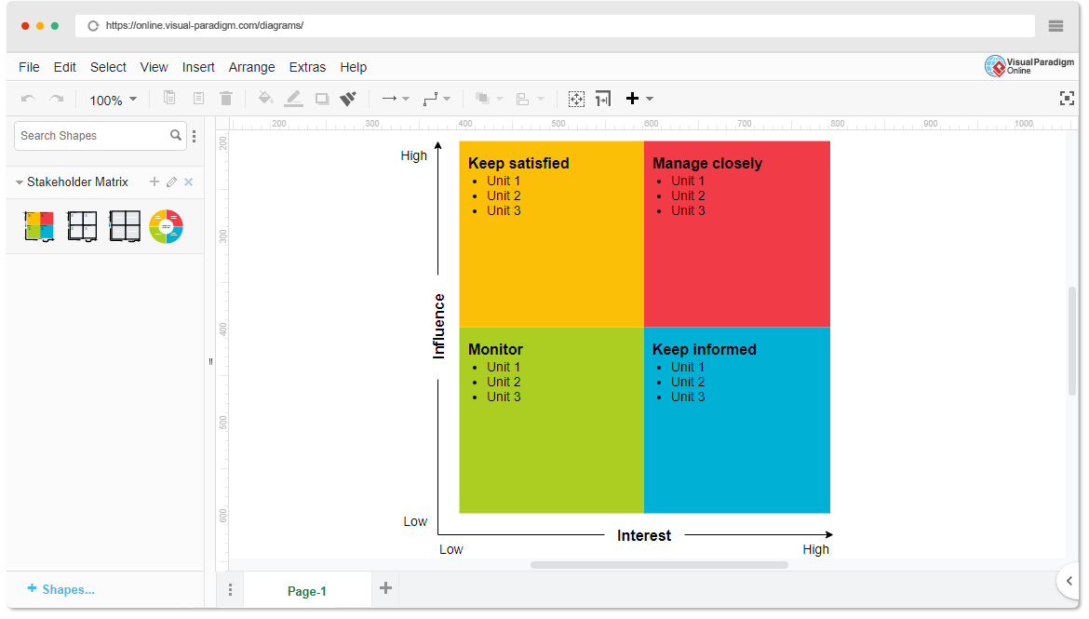

* High Power, High Interest: [Government Meteorological Departments]
* High Power, Low Interest: [Regulatory Bodies]
* Low Power, High Interest: [Meteorologists & Climate Scientists]
* Low Power, Low Interest: [General Public]

1. **Empathetic Interviews**

**Conduct Skilled interview with at least 30 citizens/Users by asking open ended questions (What, why/How etc) and list the insights as per the format below**

|  |  |  |
| --- | --- | --- |
| **I need to know**  **(thoughts, feelings, actions)** | **Questions I will ask**  **(open questions)** | **Insights I hope to gain** |
| Thoughts | What are your key expectations from this AI-powered weather forecasting system? | What are their primary goals for AI-powered weather forecasting? |
| How accurate and reliable is the AI model? | What performance metrics do you consider essential for measuring project success? | What key indicators define success for them? |
| Will this project provide a competitive edge? | What regulatory or compliance factors should we consider while developing this system? | What level of financial and technical support will they provide? |
| Feelings | How do you see AI-powered forecasting aligning with your strategic objectives? | What policies must the AI model adhere to? |
| Enthusiastic but cautious about AI's potential | How can we ensure transparency and accountability in AI-generated weather predictions? | hat legal, financial, or reputational risks need to be managed? |
| Motivated to ensure project success | What potential risks or concerns should we proactively address? | What would make them prioritize this project over others? |
| actions | What datasets or research insights could help enhance our AI model’s accuracy? | How do meteorologists and researchers want to use the system? |
| Actively participate in decision-making | How would you like to be involved in testing and validating the AI model? | What factors would improve confidence in AI forecasts? |
| Provide funding, resources, and strategic direction | What concerns, if any, do you have about AI-generated weather forecasts? | What partnerships can be leveraged for further development? |

**SKILLED INTERVIEW REPORT**

**(Examples are given. Erase them and fill with your user information.)**

|  |  |  |
| --- | --- | --- |
| **User/Interviewee** | **Questions Asked** | **Insights gained (NOT THEIR ANSWERS)** |
| Chaitanya Prakash, Student | Which political ideology do you align with? | Many citizens are frustrated by increasing fares and seek more affordable of party options |
| Naveen, brother | how do you feel about the new government about the matters? | Some people feel that medical services are expensive and not easily accessible. |
| Deepthi, sister | How do you feel about the increasing use of AI in workplaces | Some employees are worried about job security, while others see it as an opportunity for efficiency. |
| Nanvith, friend | What do you think about the quality of education in your city? | Parents are concerned about outdated curricula and lack of practical learning opportunities. |
| karthik, friend | How satisfied are you with the current waste management system? | **Many residents feel that garbage collection is inconsistent, leading to hygiene issues.** |

**Empathy Map**

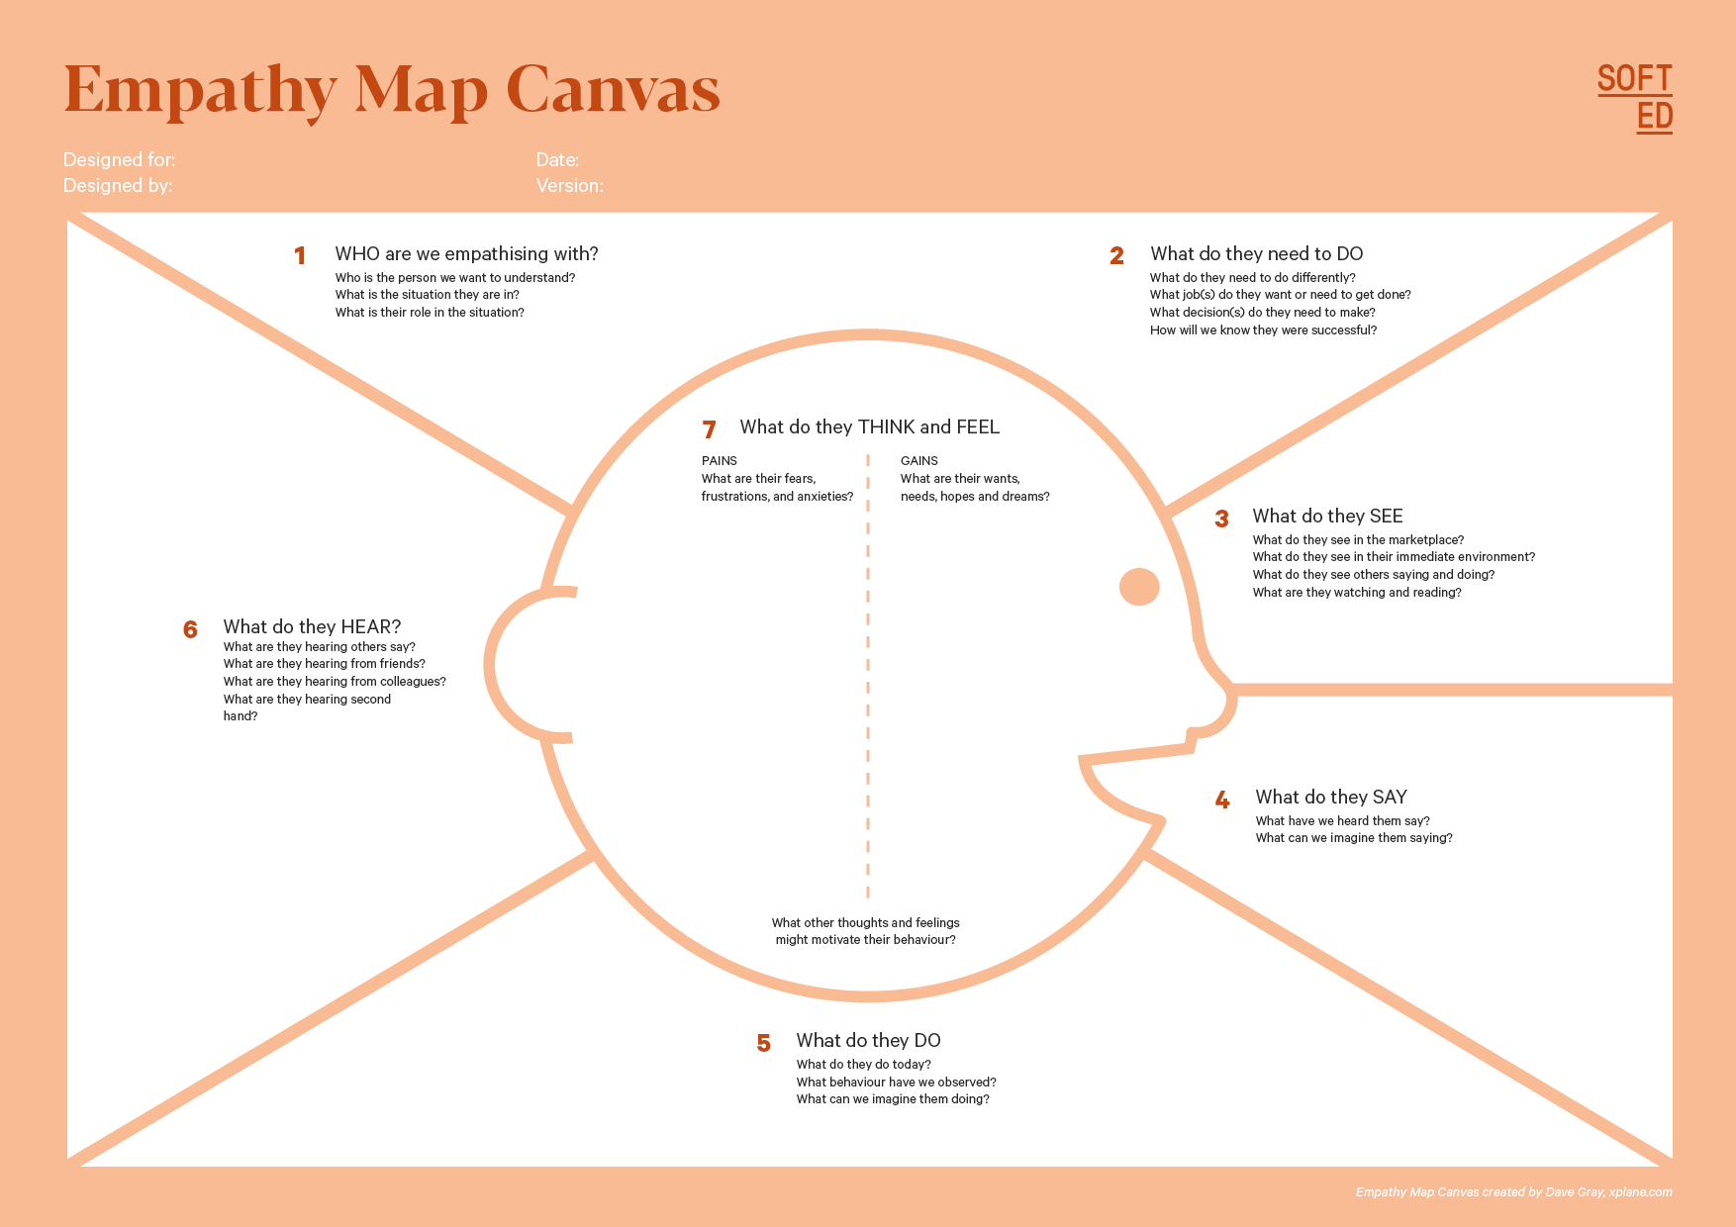

Your Answer:

Your Answer:

Who is your Customer Segment:

Idea/Innovation Title:

Designed By:

Date of Submission:

Your Answer:

Your Answer:

Your Answer:

Your Answer:

Your Answer:

Your Answer:

Your Answer:

1. **Empathy Map**
2. **Who is your Customer?**

**Description: sravani**

**Key points:**

* **45y, government, to get something new based on ai, nothing**
* **with weather prediction of using ai to make the users work easily**

1. **Who are we empathizing with?**

Description: new ai generating to get the prediction accurate to get informatio get and save life of the social people.

**Key points:**

* **the client is good, polite and very new innovative thinking**
* **to make the life very comfortable and safe to their thoughts through climate**

**8. Persona of Stakeholders**

**Stakeholder Name: sravani**

**Demographics: 45 y, urban area, dependent on weather conditions help for the farmers to make the crop very much higher.**

**Goals: Optimize weather condition, prevent crop losses, improve yield to the farmers.**

**Challenges: unreliable forecasts, climate unpredictability.**

**Aspiration: Increase farm productivity using AI-driven weather insights for farmers.**

**Needs: Real-time, accurate weather insights.**

**Pain Points: Financial loss due to sudden weather changes for farmers**

**Sample:**

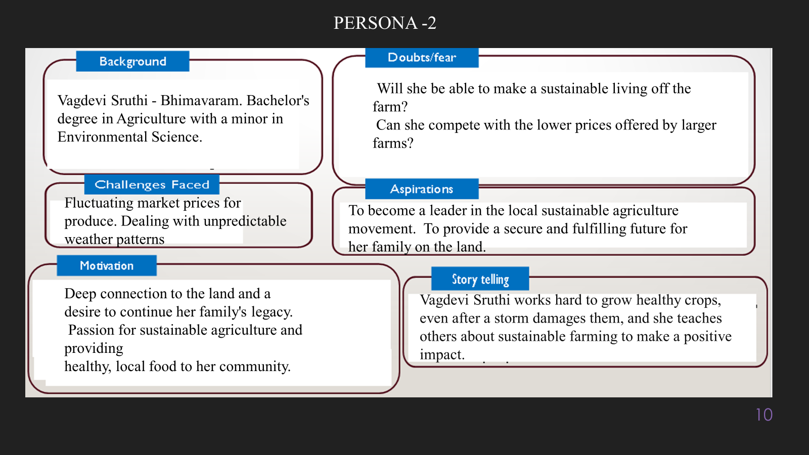

**10. Look for Common Themes, Behaviors, Needs, and Pain Points among the Users**

Analyse the data from your affinity diagram to uncover recurring patterns among your users, helping you better understand their expectations and challenges.

**Common Themes:**

**Users frequently check weather apps but find them unreliable.**

**Businesses make financial decisions based on weather data.**

**Common Behaviors:**

**Users tend to rely on past experiences, peer recommendations, or convenience when choosing a product or service.**

**Users frequently engage with digital platforms, preferring intuitive, fast, and personalized experiences.**

**Common Needs:**

**Easy-to-use AI-driven forecasting tools.**

**Affordable and accessible solutions.**

**Common Pain Points:**

**Delayed and inaccurate weather reports.**

**Lack of integration between AI and existing weather data sources.**

**12. Define Needs and Insights of Your Users**

**User Needs:**

Accurate and Timely Forecasts – Users need precise and real-time weather updates to plan their daily activities, travel, and work schedules effectively.

Severe Weather Alerts – Early warnings for extreme weather conditions (storms, floods, heatwaves) to ensure safety and preparedness.

User-Friendly Interface – A simple and intuitive platform (app/website) that displays forecasts in an easily understandable manner.

**User Insights:**

Decision-Making is Weather-Dependent – Many users make daily decisions based on weather forecasts, such as clothing choices, commute planning, and outdoor activities.

Concerns About Forecast Accuracy – Users often doubt the precision of AI-generated forecasts and seek validation from multiple sources before trusting the information.

High Demand for Extreme Weather Alerts – Users highly prioritize real-time notifications for severe weather, especially in disaster-prone areas.

**13. POV Statements**

**POV Statements:**

|  |  |  |  |
| --- | --- | --- | --- |
| **PoV Statements**  **(At least ten)** | **Role-based or Situation-Based** | **Benefit, Way to Benefit,**  **Job TBD,**  **Need (more/less)** | **PoV Questions**  **(At least one per statement)** |
| **A daily commuter who struggles with unexpected weather changes needs a reliable AI-driven weather forecasting system because sudden rain .** | **A daily commuter** who struggles with unexpected weather changes | **Accurate weather predictions** for better decision-making. | How might we ensure our AI-powered weather forecasts are more reliable than traditional methods? |
| **A farmer in a rural area who depends on weather conditions for crop growth needs accurate long-term forecasts because unpredictable weather patterns can impact planting, irrigation, and harvesting decisions.** | **A farmer in a rural area** who depends on weather conditions for crop growth | **Early warning systems** to reduce disaster impact. | How might we deliver critical weather alerts in a way that ensures immediate user action? |
| **A logistics manager who coordinates deliveries across different regions needs real-time weather alerts because extreme weather conditions can disrupt transportation and supply chain efficiency.** | **A logistics manager** who coordinates deliveries across different regions | **Improved agricultural planning** with precise rainfall forecasts. | How might we integrate AI weather predictions into logistics systems to minimize delays? |
| **An outdoor event organizer who plans large-scale activities needs a highly precise and location-specific forecast because weather conditions can determine whether an event is successful or gets canceled.** | **An outdoor event organizer** who plans large-scale activities | **Enhanced safety for travel** by predicting severe weather conditions. | How might we provide farmers with AI-driven insights that help optimize crop yield and resource usage? |
| **A disaster response team that works in emergency situations needs early warning systems for extreme weather because timely alerts can help save lives and minimize property damage.** | **A disaster response team** that works in emergency situations | **Optimized logistics and supply chain** with real-time weather updates. | How might we create a system that proactively warns individuals working or traveling in high-risk weather conditions? |
| **A city dweller who uses weather apps daily needs an AI-powered system that provides accurate and visually engaging forecasts because they rely on quick updates to plan their daily routines.** | **A city dweller** who uses weather apps daily | AI analyzes **real-time weather data** for higher accuracy. | How might we improve AI models to adapt to rapidly changing weather patterns? |
| **A pilot or airline operations manager who schedules flights needs a predictive AI-based weather model because turbulence, storms, and visibility conditions significantly impact flight safety.** | **pilot or airline operations manager** who schedules flights | Machine learning models **detect climate patterns** for better forecasting. | How might we ensure that our weather notifications are relevant and not overwhelming for users? |
| **A parent with young children who wants to plan safe outdoor activities needs a personalized weather alert system because sudden changes in temperature or air quality can affect child.** | **A government climate research analyst** who studies climate . | AI-driven alerts | How might we enable smart homes and industries to take automated actions based on weather forecasts? |

**14. Develop POV/How Might We (HMW) Questions to Transform Insights/Needs into Opportunities for Design**

1. **How might we integrate AI with real-time weather data to improve accuracy?**
2. **How might we make AI-driven weather forecasting accessible to rural farmers?**

|  |  |
| --- | --- |
| **User Need/Insight** | **"How Might We" Question** |
| **Users need highly precise, real-time weather predictions to make informed decisions.** | **How might we reduce computational costs for AI-based weather prediction?** |

**16. Crafting a Balanced and Actionable Design Challenge**

Develop an AI-driven weather forecasting system that provides real-time, hyper-local, and accurate predictions to improve decision-making for industries and individuals.

**17. Validating the Problem Statement with Stakeholders for Alignment**

**Validation Plan:**

**The engaging stakeholders through meetings, surveys, and demos to confirm the problem statement. Key questions assess relevance, impact, and gaps in current forecasting. Continuous feedback loops refine AI-based weather predictions, ensuring alignment with industry, government, and public needs.**

|  |  |  |  |
| --- | --- | --- | --- |
| **Stakeholder/User** | **Role** | **Feedback on Problem Statement** | **Suggestions for Improvement** |
| **Meteorologists** |  | **Clarity & Scope** | **Ensure the problem statement explicitly defines the gap in current forecasting methods and how AI will bridge it.** |
| **Government Agencies** |  | **Relevance** | **Focus on a specific aspect of forecasting (e.g., extreme weather prediction, agricultural weather insights, or real-time updates) for better feasibility.** |

**18. Ideation**

**Ideation Process:**

|  |  |  |  |
| --- | --- | --- | --- |
| **Idea Number** | **Proposed Solution** | **Key Features/Benefits** | **Challenges/Concerns** |
| **Idea 1** | **AI-Driven Predictive Modeling** | **High Accuracy Predictions** | **Data Quality & Availability** |
| **Idea 2** | **Real-Time Data Integration** | **Real-Time Weather Updates** | **Computational Complexity** |
| **Idea 3** | **Personalized Weather Alerts** | **Personalized Alerts & Notifications** | **Interpretability & Trust** |
| **Idea 4** | **Extreme Weather Prediction & Early Warnings** | **Early Warning for Extreme Events** | **Extreme Weather Prediction Limitations** |
| **Idea 5** | **Scalability & Multi-Platform Access** | **Multi-Platform Accessibility** | **Integration with Existing Systems** |

**Solution Concept Form**

**1. Problem Statement:**

* **Traditional weather forecasting lacks accuracy and real-time adaptability.**

**2. Target Audience:**

* **Farmers, logistics companies, government agencies, general public.**

**3. Solution Overview:**

* **AI-driven weather forecasting system using machine learning and real-time data analysis.**

**4. Key Features:**

| **Feature** | **Description** |
| --- | --- |
| **Feature 1** | **AI-based predictions with high accuracy.** |
| **Feature 2** | **Mobile and web-based accessibility.** |
| **Feature 3** | **Integration with IoT sensors for localized data collection.** |

**5. Benefits:**

| **Benefit** | **Description** |
| --- | --- |
| **Benefit 1** | **More accurate weather forecasts.** |
| **Benefit 2** | **Reduced financial losses due to weather unpredictability.** |
| **Benefit 3** | **Improved disaster preparedness.** |

**6. Unique Value Proposition (UVP):**

* **AI-powered, real-time weather forecasting with hyper-local precision.**

**7. Key Metrics:**

**Forecast Accuracy, Prediction Lead Time, Computational Efficiency**

**8. Feasibility Assessment:**

**Availability of real-time weather data from satellites, sensors, and meteorological stations.**

**Infrastructure needs, such as cloud computing resources and data storage.**

**9. Next Steps:**

* **Develop AI models, partner with meteorological agencies, and deploy a pilot project.**